June 2023

Dear Residents,

Notice of New Junction Works Starting on Leeman Road

On behalf of the York Central project team, I'm writing to let you know about work starting on a new road junction at Leeman Road bend, opposite York Self Storage and near the entrance to the Sisk project compound. This is part of wider works to build improved road and bridge infrastructure at York Central.

What will we be doing?

To make way for the planned Leeman Road West extension road, temporary single lane traffic lights will be installed at Leeman Road bend from mid-June until the end of the year.

Advance notice signage has been displayed at the roadside and close to the site since the start of June.

Why are we doing it?

This single lane traffic management system is required to convert the current road into a three-way junction.

The new junction will link up to the new spine road and join back up to Leeman Road at the Marble Arch tunnel intersection, providing a through route for vehicles, cyclists and pedestrians.

While the road is operating as a single lane, we are also able to install necessary services and utilities under the road to connect future phases of development and prevent the need for multiple road closures in this area.

This is a significant part of developing the wider York Central scheme to make progress on building a new access road to improve traffic flow.

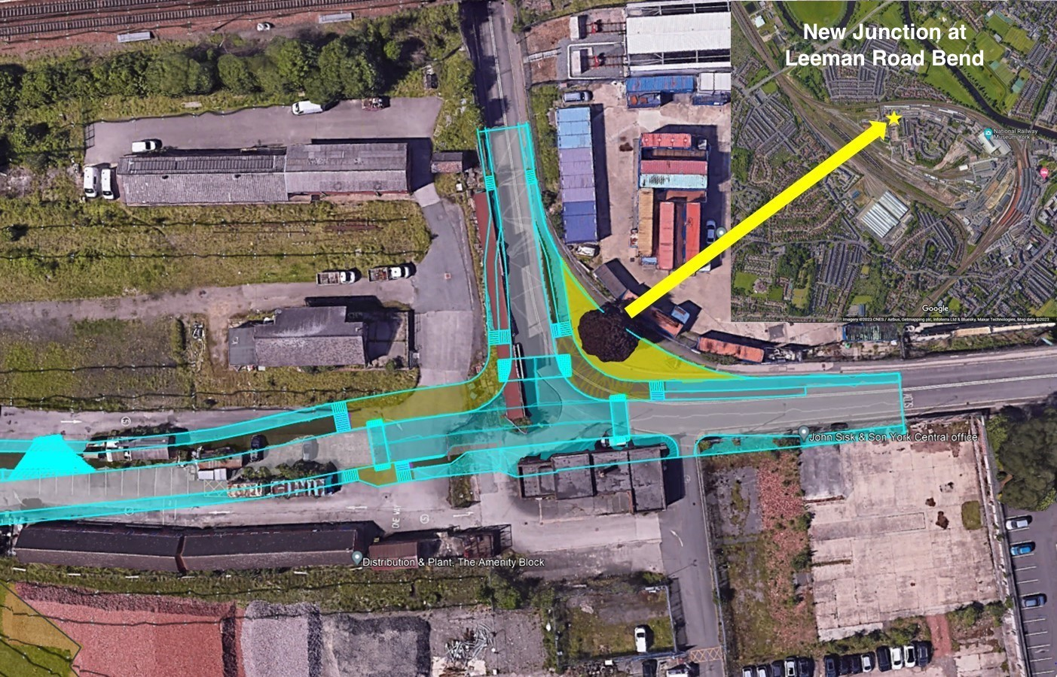

A second set of temporary traffic lights are already in place on Leeman Road at the Cinder Lane junction near Marble Arch to support works to level the ground and improve accessibility between the station and the National Railway Museum. This is also expected to remain until the end of the year.

Alternative routes/ Planning ahead

While the works are in place, pedestrian and cycle access will always be maintained, with clear signage for any diversions.

Vehicle users are advised to leave additional time for journeys and also use alternative routes during peak times, including Clifton or Poppleton Road. In addition, we encourage road users to consider using the Park and Ride services at Poppleton Bar, Rawcliffe Bar, Monk Cross, Grimston Bar or Designer Outlet.

We recognise this may cause inconvenience in the short term, particularly at peak times. However, in the longer term this will open up the site for alternative access routes with significantly upgraded facilities for vehicles, cyclists, and pedestrians.

About the York Central project

John Sisk & Son has been contracted by Homes England to deliver the infrastructure phase of the York Central project.

Once complete, York Central will provide up to 2,500 homes, 20% of which will be affordable, and over 1 million sq. ft. of commercial space for offices, retail and leisure, providing a significant boost for the local economy. It will also deliver improved connectivity and access, as well as significant public realm and open spaces, including an urban park.

How can you find out more?

If you have any enquiries about work in your area or questions about the scheme, please contact us on YorkCentral@sisk.co.uk.

We'll have regular project updates on the York Central website. You can also register for project emails by visiting www.yorkcentral.info/contact/.

For all the roadworks updates around York visit: https://www.york.gov.uk/roadworks#roadworksmap

Kind regards,

Amy Hoskin
Stakeholder and Social Value Manager
John Sisk and Son
On behalf of Homes England

